Instructional manual on how to play hockey

Name

Institutional affiliation

Date

Instructional manual on how to play hockey
Introduction
Hockey is a sport in which two teams play against each other by trying to maneuver a ball or a puck into the opponent's goal using a hockey stick. There are many types of hockey such as bandy, field hockey and ice hockey.
A typical hockey game lasts 3 periods of 20 minutes each. Each period will have a stoppage in play if the puck goes out of the rink, if there is an offside, an icing or any else that doesn't allow for proper gameplay. An NHL hockey game can last anywhere between 2-3 hours.
If the teams are tied after the third period, they go into overtime. During the regular season overtime constitutes a 5 minute long 3 vs 3 game. Whoever scores first wins. If nobody scores, the game is decided by shootout (3 shooters from each team shoot on the goalie). During playoffs there are 20 minute overtime periods of 5 vs 5 until someone scores.
Often one variation of the sport, such as field hockey or ice hockey, will predominate in a certain area and be known simply as "hockey".
The first recorded use of the word hockey is in the 1773 book Juvenile Sports and Pastimes, to Which Are Prefixed, Memoirs of the Author: Including a New Mode of Infant Education by Richard Johnson (Pseud. Master Michel Angelo), whose chapter XI was titled "New Improvements on the Game of Hockey".The belief that hockey was mentioned in a 1363 proclamation by King Edward III of England is based on modern translations of the proclamation, which was originally in Latin and explicitly forbade the games "Pilam Manualem, Pedivam, & Bacularem: & ad Canibucam & Gallorum Pugnam". The English historian and biographer John Strype did not use the word "hockey" when he translated the proclamation in 1720.
Field hockey is played on gravel, natural grass, or sand-based or water-based artificial turf, with a small, hard ball approximately 73 mm (2.9 in) in diameter. The game is popular among both males and females in many parts of the world, particularly in Europe, Asia, Australia, New Zealand, South Africa, and Argentina. In most countries, the game is played between single-sex sides, although they can be mixed-sex.
The governing body is the 126-member International Hockey Federation (FIH). Men's field hockey has been played at each Summer Olympic Games since 1908 except for 1912 and 1924, while women's field hockey has been played at the Summer Olympic Games since 1980.
Modern field hockey sticks are constructed of a composite of wood, glass fibre or carbon fibre (sometimes both) and are J-shaped, with a curved hook at the playing end, a flat surface on the playing side and a curved surface on the rear side. All sticks are right-handed – left-handed sticks are not permitted.
While field hockey in its current form appeared in mid-18th century England, primarily in schools, it was not until the first half of the 19th century that it became firmly established. The first club was created in 1849 at Blackheath in south-east London. Field hockey is the national sport of Pakistan. It was the national sport of India until the Ministry of Youth Affairs and Sports declared in August 2012 that India has no national sport
Ice hockey is played between two teams of skaters on a large flat area of ice, using a three-inch-diameter (76.2 mm) vulcanized rubber disc called a puck. This puck is often frozen before high-level games to decrease the amount of bouncing and friction on the ice. The game is played all over North America, Europe and to varying extents in many other countries around the world. It is the most popular sport in Canada, Finland, Latvia, the Czech Republic, and Slovakia. Ice hockey is the national sport of Latvia and the national winter sport of Canada. Ice hockey is played at a number of levels, by all ages.
Equipment for hockey playing
Stick
Your hockey stick is like your weapon on the battlefield. After choosing the most suitable hockey stick for yourself, you will learn to use it and after a while, be so comfortable with it that it becomes a part of you.
Shoes
The type of shoes you should get depends on the type of surface you’re going to play on.
If you’re playing on grass field then cleats are the most suitable as their soles have large studs hence allowing for better grip, quicker cuts and faster transitions. If you’re playing on artificial turf, you might want to invest some money into turf shoes which have smaller studs, perfect for gripping on the artificial turf.
But if you’re playing indoors, you can just get some running shoes which have grooves on their soles for maximum grip on smooth surfaces.
Mouth Guard
Investing in a mouth guard is a good idea because you wouldn’t want to burn a hole in your wallet, paying for your dental treatment should a ball hit you in the face.
Shin Guards
When you play field hockey, your shins take the most beating from balls and sticks. It is thus important for you to protect your shins from getting bruised.
Socks and Rash Guards
Socks are pretty common sense. If you refuse to wear socks then, brace yourself for the blisters. Rash guards on the other hand, are optional. They go under your shin guards and protect your shin from getting constantly rubbed against the shin guards.
Stick Bag
A stick bag is optional too but they’re definitely going to be convenient if you’re going to be carrying multiple sticks at one go.
Electrical Tape
Electrical tape is really useful and if you tape them to the bottom of your stick, it’d protect your stick from dents and wear and tear! If you’re a beginner, taping the bottom of your stick would also aid in stopping the ball.
Grip
If you’re going to be using your hockey stick regularly, then you would realise that the grip at the top wears easily. Buying and replacing grips would be common once you become a hockey player.
Ball
Finally, you can’t play field hockey without a ball! But we are putting this under personal equipment too because you should have a personal ball for practice. if you’re a beginner, get a turf ball to practice instead of the regular practice ball. Field hockey balls are rubber-like, hard and dense and they travel quickly.
Helmet
The helmet protects your head and face from injury. When you’re buying a helmet, the most important thing you should take note of is that it fits your head comfortably.
Throat Protector
The throat protector wraps around your neck and is essential in protecting the goalies throat against fast moving balls.
Chest Pad
The chest pad protects the goalie’s torso and is padded in front.
Arms and Elbow Protector
Your body armor wouldn’t be complete without your arm and elbow protector. They keep your arms and elbows safely padded just in case the ball decides to hit you there. Though you don’t often get hit in those areas, it’s always better to be safe than sorry!
Right and Left Hand Protector
The right hand protector is hard and rounded, designed to fit around the stick. On other hand, the left hand protector is flat and stiff to enable the goalie to stop lifted shots.
Goalie Pants
Protecting your lower body is also important for a goalie. The goalie pants provide extra protection to the upper legs, hips and groin from shots.
Groin/Pelvic Protector
If you’re a goalie, you’re going to appreciate the groin protector.
Leg Guards
Although the goalie pants protect your upper legs, it doesn’t do much for your lower legs. This is where the leg guards come in handy. They cover all the way from the top of your feet to the top of your knee.
Kickers
Kickers also protect your legs and shin. They usually come with the leg guards as a set.
Once you’ve got all the equipment that you need, it’s time that you head out to the field and practice! Whether you want to do some shooting drills or dribbling drills, always remember that practice makes perfect!
Instructions on playing hockey
(Hockey signs and symbols)
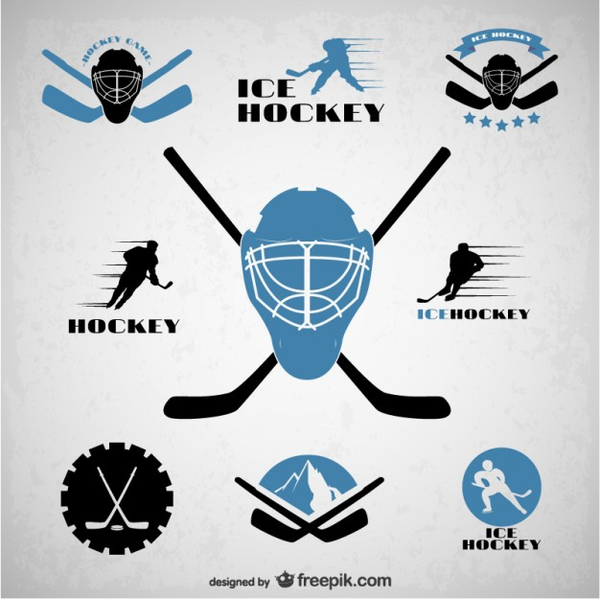

(how to hit a hockey ball)
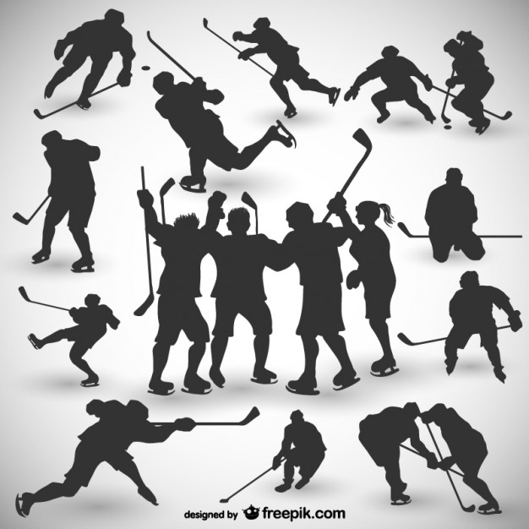

(hockey field set up)

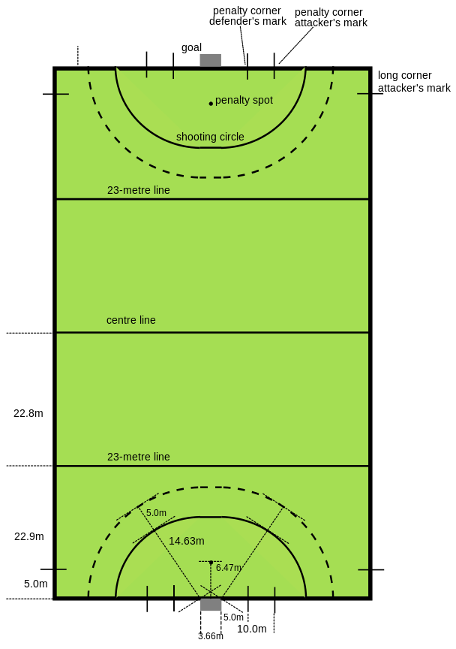
(Hockey graphics during the medieval ages)

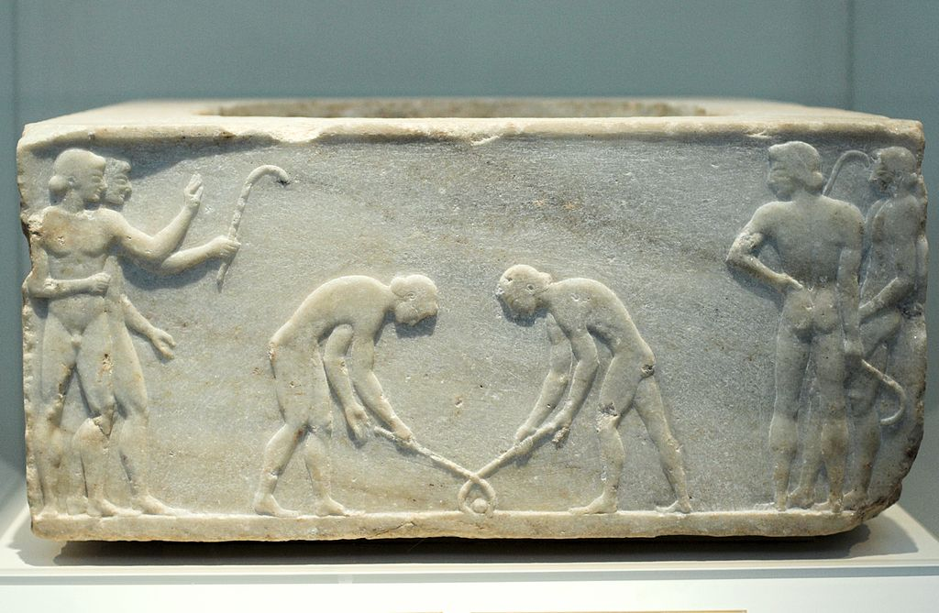

Warnings and statements in a hockey
You may only use the flat side of your stick.
You must be properly attired – shin guards, mouth guards, no jewelry, etc.
10 field players plus a goalie play at one time.
The field hockey game lasts for two 30 minute halves.
Substitutions – the field player must exit the field at the 50, only then can the new player step onto the field.
The ball cannot go in the air, especially on free hits. This is judged by the discretion of the ref. The exception is a shot on goal, as long as there is not a player in the direct line of the ball and no one is in harm’s way.
Self –start. When taking a hit into the circle, whether it is a free hit or long hit, you cannot directly hit into the circle. You must pass it first or carry the ball for 5 yards before hitting the ball into the circle.

For free hits anywhere else on the field, you may either: take a direct hit, pass to one of your players, or carry the ball for 3 yards before hitting it.
Any time a foul occurs in either team’s circle, a corner hit will be called.

Fouls
The ball cannot hit your feet.
You cannot raise your stick above your waste during regular play. If you are taking a free hit, it is up to the discretion of the ref.
You cannot tackle (go for the ball) from behind. You must face your opponent head on (shoulder to shoulder) if you are fighting for the ball.
No third party. It is one vs. one at all times. Once another player tries to go for the ball, a foul is called.
Obstruction – when your back is turned to another player and you are between the ball and that player.

References
Emery, C. A., & Meeuwisse, W. H. (2006). Injury rates, risk factors, and mechanisms of injury in minor hockey. The American journal of sports medicine, 34(12), 1960-1969.
Kale, R. (2012). Stop the violence and play hockey.

